RGM3: Editing and Revising Text

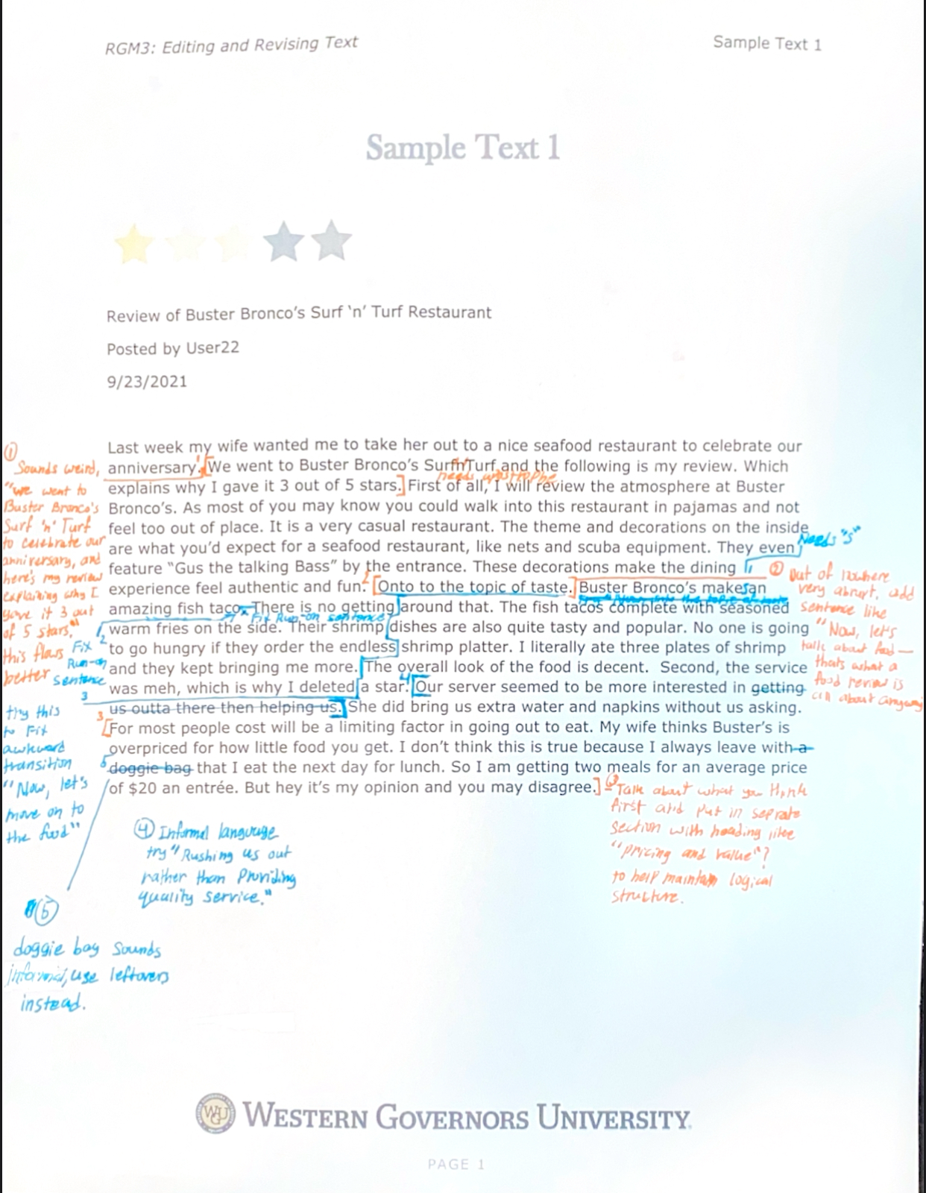Part A:

Part B: 3 Revisions:

1. The introduction needed to be changed to bring more clarity and eliminate sentence fragment to set up the whole review.  
   “We went to Busters Broncos Surf ‘n’ Turf to celebrate our anniversary, and here’s my review explaining why I gave it 3 out of 5 stars”
2. Transition to food was very abrupt so it had to be changed to improve flow and readability.  
   “Now, let’s talk about food—that’s what a food reviews all about anyways.”
3. The cost discussions should be moved for better organization by placing it with a header like “pricing and value” that is towards the end.

5 Edits:

1. Fixing sentence structures can improve speech fluidity.   
   Original: “Buster Bronco’s make an amazing fish taco. There is no getting around that.”   
   Edit: “Buster Bronco’s makes amazing fish tacos—there’s no getting around that.
2. Correcting verb agreements to have proper grammar.

Original: "Buster Bronco’s make an amazing fish taco."  
Edit: "Buster Bronco’s makes an amazing fish taco."

Singular nouns deserve a singular verb- so the noun, Buster Bronco’s, is singular, while “make” is a plural verb.

1. Using formal language is an indicator of knowledgeability and credibility. Informal language is unprofessional, and you may not be taken seriously.

Original: "Our server seemed to be more interested in getting us outta there then helping us."

Edit: "Our server seemed keen on rushing us out rather than providing quality service."

1. Word choice is important to provide clear and appropriate writing for your readers.

Original: "I always leave with a doggie bag that I eat the next day for lunch."

Edit: "I always leave with leftovers that I will eat for lunch the next day."

1. Transitions shouldn’t be awkward and should flow into your next topic or sentence.

Original: "Onto to the topic of taste."

Edit: "Now, let’s talk about the food."

Part C:

The introduction seems very lack-luster and unprofessional, due to how its written and formatted. In addition, the first couple sentences look informal, and the explanation behind their review isn’t very clear right off the bat.

The greatest strength within this review is how descriptive it is, it really sets the scene and setting well.

The weakest strength is the word choices and how the review is visually. There are plenty of instances of informal language, and awkwardness within and between sentences.

The conclusion is very abrupt and would leave a reader confused because it doesn’t detail whether they would return or why they rated it lower. There’s a lack of balance throughout the entire review, the writer only points out one real negative, and the rest of the review is just describing their experience. The conclusion should wrap up all their negative and positive feelings on the restaurant.